Tab 1

StockSense: Web-Based Inventory Accuracy & Alert System
Group 3 - BM1
Team Lead:
Virtucio, Ranzel Jude M.
Members:
Agapito, Raphael Lian C.
Correa, Melprin O.
Sagun, Arthur V.

January 15, 2026

I. Background and Project Scope

The current inventory management workflow at the target facility is characterized by a centralized, Excel-based tracking system that creates a significant "Information Lag," resulting in a 168-hour delay between physical stock movement and digital record updates. This bottleneck requires administrative staff to dedicate approximately two hours weekly to manual shelf verification, leading to "Phantom Stock" errors and potential production halts when critical machine parts are unknowingly depleted. StockSense is a web-based management information system designed to decentralize this process by allowing warehouse floor staff to synchronize physical reality with digital records in real-time via mobile-optimized browser interfaces. By implementing a localized, real-time tracking architecture, the system mitigates the risk of stockouts and ensures 100% data integrity for items reserved under specific Maintenance Agreements (MA).

II. Proposed Solution
The system's Functional Requirements focus on reducing the high friction of current data entry methods through a "One-Click" transaction model. Specifically, the software must provide a mobile search utility for real-time availability checks, incremental stock update buttons ("+" and "-") for immediate recording, and a specialized allocation toggle to distinguish between "Available" and "Reserved" stock levels. Non-Functional Requirements prioritize the "Human Kernel" by emphasizing high usability for high-pressure environments, web-based accessibility to avoid specialized hardware costs, and extreme reliability to protect the business’s contractual obligations regarding machine part availability.

C. Proposed System Flow

i. Context Diagram (Level 0)

The Context Diagram serves as the foundational "Environment Model," establishing the hard boundary of the StockSense ecosystem and its relationship with critical external stakeholders. From a user experience perspective, it depicts a low-friction exchange where Warehouse Staff provide live "In/Out" telemetry and receive immediate "Real-Time Availability" feedback, effectively eliminating the operational friction of manual shelf verification. Simultaneously, it reinforces business viability by positioning the Admin as the primary control node for "Allocation" requests—ensuring high-priority machine parts are protected—while the system automates risk mitigation through "Low Stock Reports" that maintain the health of the supply chain.

By mapping these high-voltage data flows between the system and its sources or sinks, the diagram ensures that every piece of information is prioritized based on its impact on inventory accuracy and departmental accountability. Without this clearly defined environmental boundary, the system enters a state of "Logical Leakage," where unverified data sources corrupt the inventory master list and lead to a total collapse of the procurement chain.

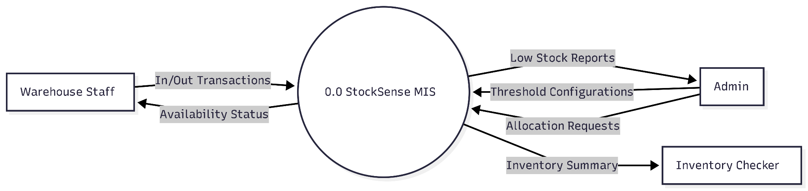

ii. Level 0 DFD
The Level 0 Data Flow Diagram serves as the functional blueprint for the StockSense ecosystem, partitioning the system into four manageable logical subsystems to ensure operational clarity and data integrity. At the core of the Transaction Layer, Stock Management facilitates the fluid movement of Inbound, Outbound, and Dispatch data, reducing the administrative friction typically associated with manual logging. To safeguard business viability, the Allocation Engine provides a critical logic bridge by distinguishing between reserved and available stock, ensuring that parts promised under Maintenance Agreements are never accidentally depleted for general repairs.
This is supported by the Alert and Monitoring subsystem, which enhances the user experience by translating backend telemetry into immediate visual cues, allowing floor staff to navigate stock levels without manual audits. Finally, the Reporting subsystem consolidates these interactions into a "Daily Summary," providing stakeholders with the high-voltage visibility required for strategic oversight and long-term planning.
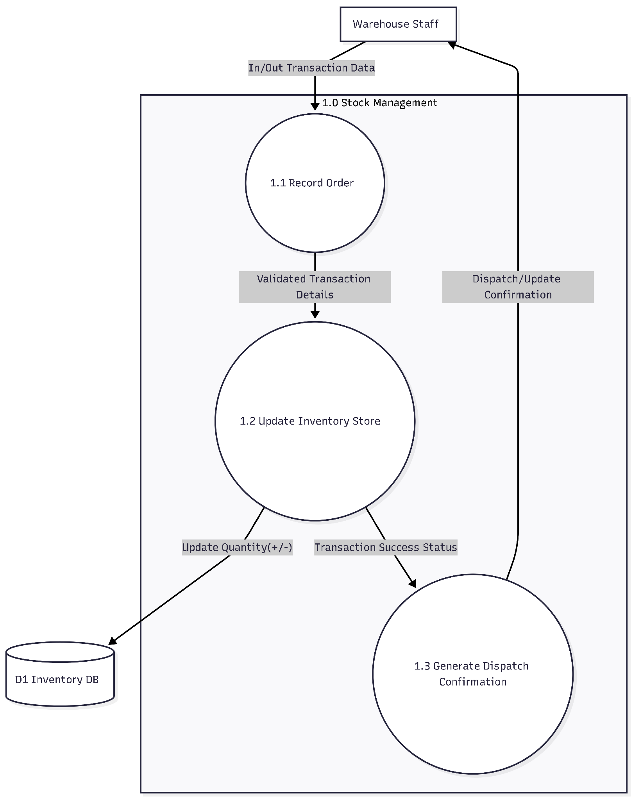
Without this structural decomposition, the system degrades into a simple counter that fails to differentiate between physical stock and contractual availability, resulting in a system collapse where critical part shortages are only identified after they have already halted production.

iii. Level 1 DFD
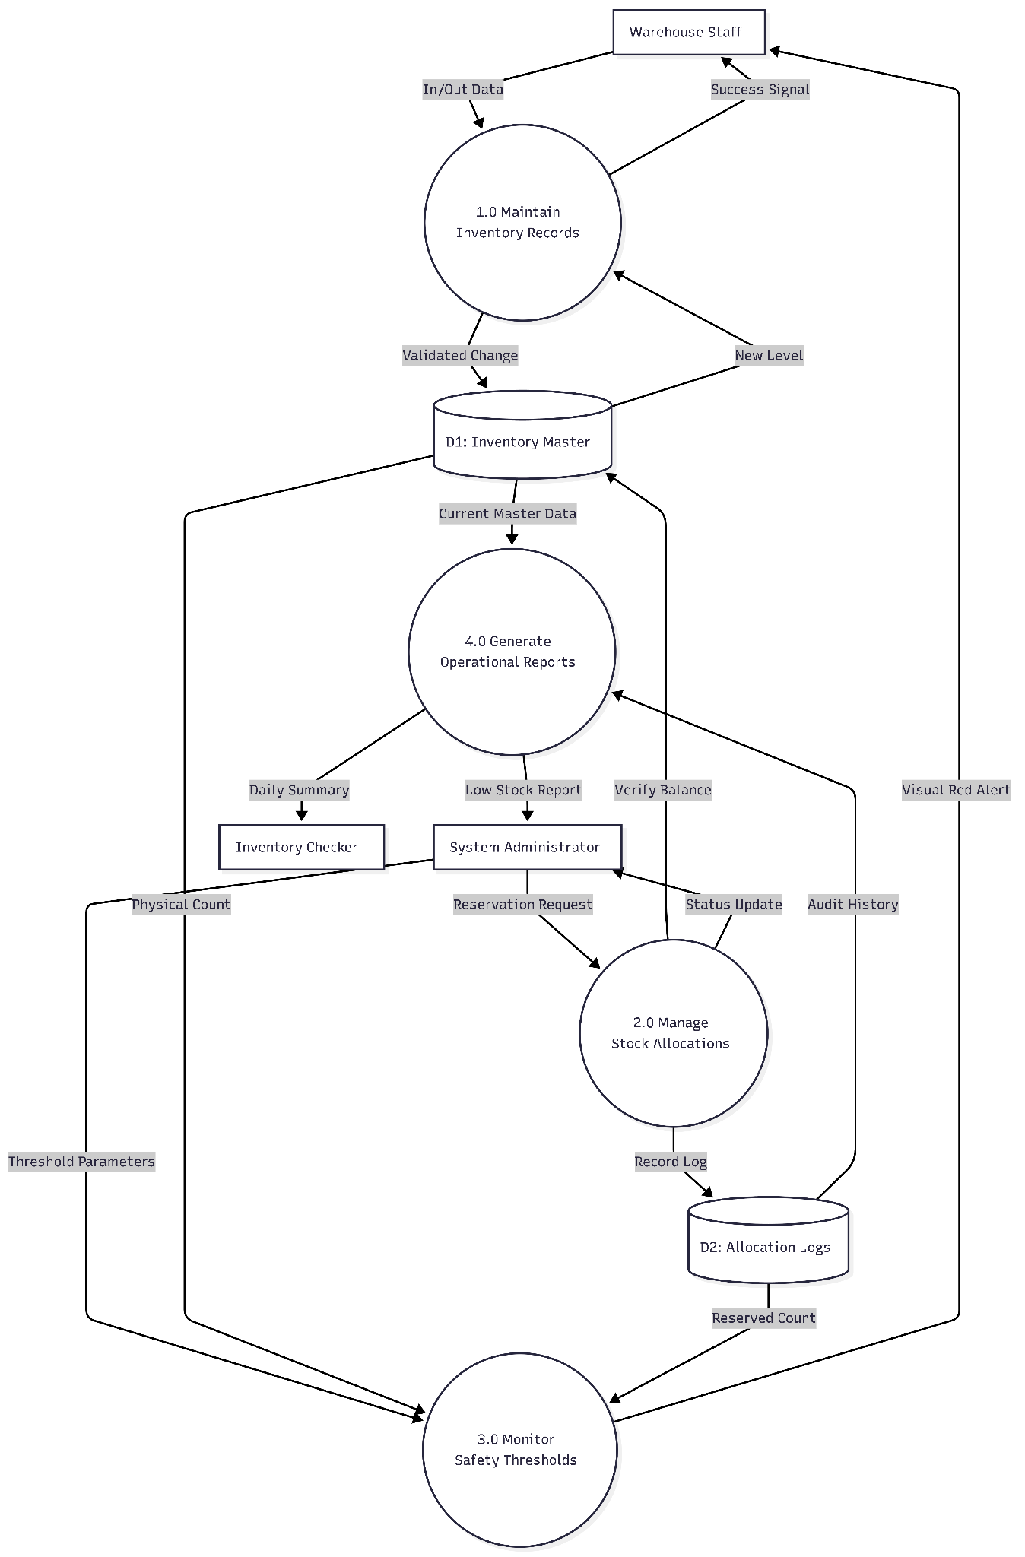
The Level 1 Data Flow Diagram provides a granular decomposition of the "Stock Management" process, transforming a physical warehouse movement into a verifiable digital record through three sequential sub-processes. Initially, the system executes Record Order, which captures raw "In/Out" telemetry from the mobile interface to ensure that technician intent is documented at the exact point of activity. This validated transaction data flows into Update Inventory Store, the central logic engine that performs the mathematical adjustment within the Inventory Master (D1) while simultaneously populating the Allocation Logs (D2) to preserve a perfect audit trail of part movement. Finally, the system initiates Generate Dispatch Confirmation, which triggers an immediate success signal back to the user’s mobile device, providing the necessary closure to prevent duplicate entries and complete the real-time synchronization loop.

iv. Decomposition (Hierarchy)
The functional architecture is organized into a tiered hierarchy to ensure modularity and operational reliability, separating user interactions from the core business rules. At the foundational level, the Transaction Layer handles the high-velocity, mobile-optimized data entry for real-time "In, Out, and Dispatch" movements, ensuring immediate synchronization between the warehouse floor and the digital record. The Logic Layer acts as the system's internal engine, governing the complex mathematical intersection of allocation management and threshold monitoring to protect the business's contractual obligations. Finally, the Presentation Layer serves as the visibility engine, transforming raw logic into a high-voltage Visual Dashboard and automated Reporting suite that eliminates the information lag typical of manual audits.
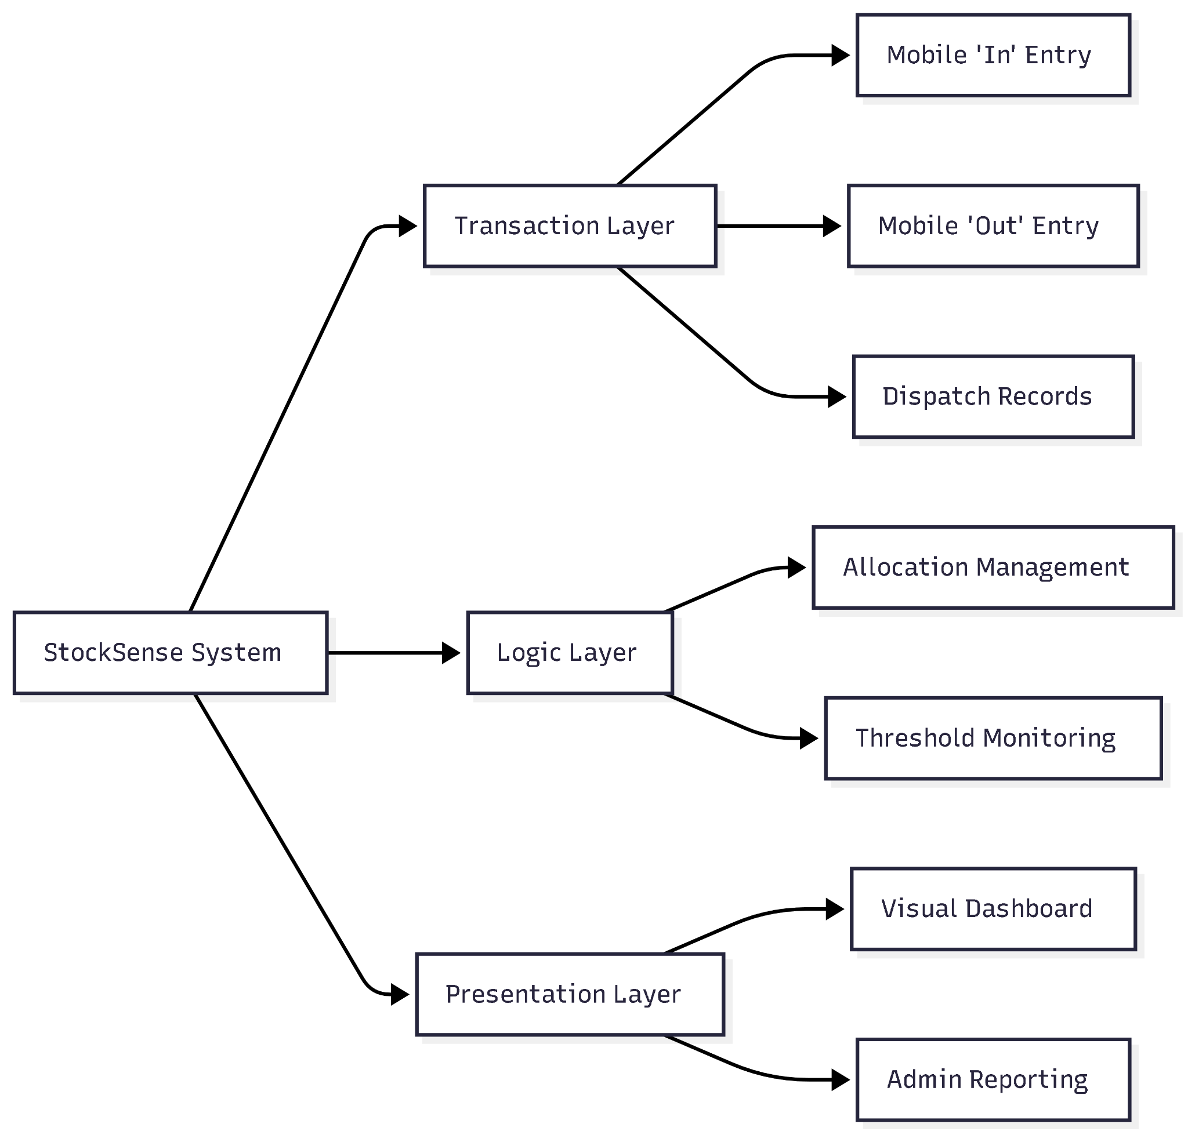

v. Data Dictionary (The "Logic Standard")

The Data Dictionary defines the exact "Hardware Telemetry" moving through the "Arrows" of your DFD. Each entry ensures that the system logic has the necessary variables to execute "In/Out" transactions and "Red" alerts without data corruption.

1. Data Flow Definitions
These entries describe the information packets moving between entities and processes.
Stock Update Packet: This flow originates from the Warehouse Staff and contains the unique Item_ID, the Transaction_Type (In/Out), the Quantity_Change (Integer), and a Staff_Timestamp to ensure the "One-Click" update is recorded at the exact point of activity.
Threshold Configuration: Sent by the Admin to the Monitoring process, this packet includes the Item_ID and the Minimum_Safety_Level, which acts as the mathematical baseline for triggering "Red" visual cues on the dashboard.
Allocation Request: A data packet containing Item_ID, Reserved_Quantity, and Project_Reference, allowing the Allocation Engine to lock stock for specific Maintenance Agreements (MA).
Inventory Alert Signal: An output flow sent to the Presentation Layer containing Item_ID, Current_Status (Normal/Low), and the calculated Alert_Color to reduce the user’s cognitive load during high-pressure audits.

2. Data Store Definitions
These entries define the "Permanent Memory" structures (Open-Ended Rectangles) in your DFD.
D1: Inventory Master: A central repository containing the Master_Item_Record, which includes Current_Physical_Count, Unit_Cost, and Lead_Time_Data to support the business viability of the warehouse.
D2: Allocation Logs: A specialized store that tracks the "Software Execution" of stock reservations, holding Log_ID, Allocation_Status (Active/Released), and the User_ID of the individual responsible for the reservation.

Questions asked to Rapha's Dad

Proposed Solution (StockSense)

Business Value (Cost/Risk)
Current System (Problem) | Proposed Solution (StockSense) | Business Value (Cost/Risk)
Centralized Bottleneck: Records are saved on a single office computer. | Web-Based Accessibility: Accessible via phone browsers anywhere in the warehouse. | Reduced Labor: Eliminates the walk-time between the warehouse floor and the office.
Information Lag: 168-hour delay due to weekly manual reports and audits. | Real-time Availability: Instant "In & Out" tracking for dispatch and allocation. | Risk Mitigation: Prevents "Ghost Stock" and accidental over-allocation of parts.
Manual Friction: Updating stock requires manual report writing or complex spreadsheet entry. | One-Click Update: Simple "+" or "-" interface for immediate stock adjustments. | Data Integrity: Encourages staff to do record transactions in specific date and time accordingly at the moment of physical execution.
Reactive Monitoring: Management only realizes items are low during the weekly check. | Visual Dashboard: Color-coded cues (Red for low stock) for instant identification. | Operational Continuity: Reduces production downtime by enabling proactive procurement.
High Audit Overhead: 2 hours per week spent on manual verification. | Automated Reporting: Generates a "Daily Summary" history log or "Low Stock Report" instantly. | Cost Savings: Reclaims 100+ hours of annual labor currently spent on manual counting.

Summary of "The Why" for Your Professor
The core justification for this project is the shift from a Post-Mortem Record to a Live Navigator.

- The Goal: To achieve "Real-time Availability" of machine parts to support dispatch and allocation.
- The Impact: Currently, all equipment is under warranty or maintenance agreements, meaning missing a single part for a repair is not just a delay—it is a breach of service efficiency.
- The Constraint: By replacing the current Excel-based system (which lacks automated alerts) with a visual, browser-based dashboard, we remove the "Human Error" variable in data entry.

System Collapse Factor: Without the Real-time Synchronization between the warehouse floor and the digital record, the entire procurement chain collapses into a state of "Information Entropy," where the business is forced to stop operations just to count boxes.

System Maintenance & Accountability
For the StockSense proposal, the "Update and Maintenance" phase ensures that the transition from a manual Excel-based environment to a real-time web system remains reliable and accurate. Based on the requirement for Real-Time Availability and the "One-Click" update system, the following roles are assigned to manage the software's data integrity:

1. Warehouse Staff/Technicians (Recording Logs)
- The primary responsibility for recording logs falls on the Warehouse Staff/Technicians.
- Operational Flow: As they physically handle machine parts for dispatch or emergency repairs, they use their phone browsers to execute the "In/Out" transactions.
- Audit Trail: Every "+" or "-" click is automatically timestamped and logged, replacing the previous manual paper logs or single-PC Excel updates.

2. The Admin Account (Management & Configuration)
- The Admin Account (typically the Warehouse Manager or Team Lead) handles the "Maintenance" of the system's logic:
  - Threshold Setting: Defining the "Set Number" for each item that triggers the "Red" visual cue on the dashboard.
  - User Management: Granting or revoking access to the web-based system for new staff or technicians.
  - Data Resolution: Correcting entries if a "One-Click Update" was performed in error.

3. The Checker (Inventory Auditor/Employee)
- The Checker role is responsible for the "Verification Labor" previously done manually:
  - Validation: Periodically comparing the digital "Real-Time Availability" dashboard against the physical shelves to ensure zero "Data Drift."
  - Report Review: Reviewing the system-generated "Low Stock Report" and "Daily Summary" before they are sent to procurement.

Functional Roles Comparison
Role | Primary Responsibility | Key System Interaction
Warehouse Staff | Real-time Recording | One-Click "In/Out" Updates via Mobile
Admin Account | System Maintenance | Setting Stock Thresholds & User Permissions
Inventory Checker | Accuracy Verification | Cross-referencing Dashboard with Physical Stock

Business Viability & User Experience
- Cost/Risk: By assigning specific "Checker" and "Admin" roles, the business mitigates the risk of unauthorized stock adjustments and ensures the 2-hour weekly verification labor is spent on high-value auditing rather than basic data entry.
- Friction/Flow: The "Admin" maintains the system's "Alert Velocity". If the Admin sets accurate thresholds, the "Checker" and "Procurement" teams only need to act when the system pushes a "Red" alert, removing the need for constant, manual monitoring.

System Collapse Factor: Without clearly defined roles for Admin Maintenance and Staff Recording, the system becomes a "Shared Spreadsheet" without accountability, leading back to the same manual tracking errors and delayed updates it was designed to solve.

Functional/Non-Functional Requirements
Melprin Correa

- Stock Search & Update: The system must allow users to search for specific inventory items and update stock levels using "+" or "-" buttons.
- Visual Dashboard: The system must display a web-based dashboard that provides real-time visual cues of current stock levels.
- Low-Stock Alerts: The system must automatically change an item's status color to "Red" when stock levels drop below a pre-defined threshold.
- Report Generation: The system must generate a printable "Low Stock Report" list at the end of each day as a daily summary.

Ranzel Virtucio

High-Priority Functional Requirements (The "Must-Haves")
These features directly address the current system's failure points—centralized access and manual reporting.
- Mobile Item Search & Availability: A lightweight search bar allowing staff to verify "Real-Time Availability" before walking to a shelf.
- One-Click "In & Out" Transactions: A mobile-optimized interface with "+" and "-" buttons for immediate stock updates, replacing manual paper logs.
- Basic Allocation Status: A simple toggle or field to mark stock as "Allocated" (reserved for Maintenance Agreements) or "Available" for dispatch.
- Color-Coded Dashboard: Visual indicators that turn "Red" when stock levels drop below the pre-set safety threshold.

2. Plausible Non-Functional Requirements
To ensure the system is usable by March 21, we focus on Flow over complex "Plumbing."
- Mobile Responsiveness: Ensuring the web application is fully functional on standard smartphone browsers so it can be used on the warehouse floor.
- Low-Latency Synchronization: Updates must reflect across the system within seconds to eliminate the current weekly delay.
- User Interaction Simplicity (Frictionless Flow): Minimizing data entry to essential clicks, ensuring the "2-hour weekly verification" labor is reduced.

summary
The StockSense specification document outlines a web-based solution designed to modernize manual warehouse inventory tracking. It addresses the operational risks caused by centralized, Excel-based systems by providing real-time, mobile-accessible monitoring and alerts.
-----Project Overview
- Project Title: StockSense: Web-Based Inventory Accuracy & Alert System.
- Lead & Team: Virtucio, Ranzel Jude M. (Lead), Raphael Lian C. Agapito, Melprin O. Correa, and Arthur V. Sagun.
- Core Objective: To shift from "Post-Mortem" records to a "Live Navigator" system that ensures real-time availability of critical machine parts.
-----Problem Analysis

The current Excel-driven workflow creates three primary business risks:
- Information Lag: Weekly audits lead to a 168-hour delay in data accuracy.
- Labor Inefficiency: Staff must spend two hours weekly manually verifying digital records against physical shelf counts.
- "Phantom Stock": Centralized access prevents immediate updates, leading to unrecorded part movements and potential production halts.
-----Proposed Solution Requirements

The system is built on low-friction, mobile-first requirements to encourage immediate data entry.Functional Requirements
- Mobile Search: A lightweight bar for verifying availability before walking to a shelf.
- One-Click Transactions: "+" and "-" buttons for instant updates via smartphone.
- Allocation Status: A toggle to reserve stock for specific Maintenance Agreements (MA).
- Visual Dashboard: Automatic "Red" indicators when stock drops below safety thresholds.
Non-Functional Requirements
- Accessibility: Must be browser-based for warehouse floor use.
- Synchronization: Updates must reflect across the system within seconds.
- Reliability: 100% data integrity between "Allocated" and "Available" stock is mandatory.

-----System Architecture & Flows

The system logic is decomposed into three primary layers: Transaction (In/Out), Logic (Allocation/Thresholds), and Presentation (Dashboard/Reporting).User Roles & Accountability
Role | Primary Responsibility | Key Interaction
Warehouse Staff | Real-time Recording | Mobile "In/Out" updates
Admin Account | System Maintenance | Setting thresholds & permissions
Inventory Checker | Accuracy Verification | Cross-referencing dashboard with shelves

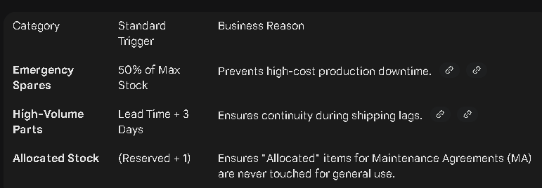

Flowchart of Transaction Process
To visualize the system's core function, the following flowchart illustrates the steps a Warehouse Staff member takes when executing a one-click inventory transaction, which immediately feeds the Logic Layer described above.

Transaction: Part Check-Out (Decrement Stock)
- User Action: Warehouse Staff member selects a part via the Mobile Search bar.
- Input: User taps the " - " (Decrement) button on the mobile UI.
- Data Capture: A modal appears, requiring input for:
  - Quantity Taken
  - Purpose (e.g., Production Line 1 Repair, MA-47 Service)
  - (Optional) Receiver Name/ID
- Database Update: The Transaction Layer executes the SQL command: UPDATE Inventory_DB SET Current_Stock = Current_Stock - [Quantity Taken] WHERE Item_ID = [Selected_ID].
- Logic Layer Trigger: Immediately following the update, the Logic Layer runs the Threshold Logic Table checks.
- UX Feedback:
  - If no alert is triggered, a Transaction Success toast message appears.
  - If an alert is triggered (e.g., Current_Stock is now below the Critical Spares threshold), the system generates the appropriate Red Alert flag on the dashboard in near real-time, fulfilling the Synchronization non-functional requirement.
- Final State: The transaction is logged in the Transaction_History table for audit purposes. This is the new "Live Navigator" state.

database things
If you choose Option 3 (Allocation Logs), your professor will likely ask about it, but here is the strategic advantage: you have already included "Allocation Logs" in the Data Flow Diagrams (DFDs) of your submitted document.
By choosing Option 3, you are not adding a new feature; you are simply defining the "Software Execution" for a component you have already promised in your architectural visuals.

Why the Professor Will Ask (The Logic Gap)
In your current specification, there is a slight discrepancy between your "Requirements" and your "Flows" that your professor might spot:
- The Requirement: You described "Allocation Status" as a "simple toggle or field." This implies a simple "Option 1" (Flat Table) approach.
- The DFD: Your Level 0 and Level 1 DFDs explicitly name "Allocation Logs" (DS2) as a data store and an "Allocation Engine" as a subprocess.
If you use Option 3, you are closing this gap. You can explain that the "Simple Toggle" the user sees is actually the trigger that writes a detailed entry into the Allocation Logs data store shown in your diagrams.

Explaining Option 3 to your Professor
When asked, you should frame Option 3 through Business Viability and Reliability:
- Business Viability (Risk Mitigation): "We chose an Allocation Log approach to support the Maintenance Agreements (MA) mentioned in our Non-Functional Requirements. A simple toggle is too risky for expensive machine parts; we need an audit trail of who reserved the stock and why to ensure 100% data integrity."
- User Experience (Transparency): "Instead of the Inventory Checker just seeing a number, the logs allow them to see the history of reservations. This reduces friction during audits because the 'Allocated' status is backed by evidence, not just a static flag."

The Technical Trade-off
Since your team is currently in the "Vibe-Coding" phase, you must weigh the complexity:
- The Plumbing: Your Backend Lead will need to write a query that sums up all active logs to determine the Total_Allocated quantity.
- The Benefit: It prevents "Phantom Stock" errors where someone untoggles a part by mistake without leaving a record.
System Collapse: Without the Allocation Logs you've already diagrammed, the system loses its "Memory." If an item is marked as reserved for a critical maintenance contract but there is no log explaining why, the system fails its primary goal of providing reliable equipment support, leading to contractual penalties and production downtime.

Design Interfaces
This is the "Full System Telemetry" for StockSense as of February 5, 2026. This summary consolidates the architectural decisions, business logic, and team assignments into a single source of truth for your next development cycle.

1. Executive Summary: The Business Case
StockSense is transforming from a passive ledger into a Decision Support Tool.
* The Primary Friction: A 168-hour "Information Lag" caused by manual Excel updates.
* The Solution: A mobile-synchronized interface that eliminates "Phantom Stock" by matching digital records to physical reality in real-time.
* Risk Mitigation: The system protects cash flow by preventing "Trapped Capital" (overstocking) and "Production Halts" (stockouts).

2. Core System Requirements (The "What")
We have expanded the initial scope to include deep traceability and lifecycle management:
* Identification & Sourcing: Item Code, Description, Vendor, and Date Delivered.
* Lifecycle Tracking: Warranty Start/End dates to ensure maintenance is covered by manufacturers rather than internal costs.
* Movement Logic ("Saan Napunta"): Every transaction must log a Destination/Recipient and a Purpose/Work Order.
* Guardrails: Real-time "Red Alerts" for stockouts and "Ceiling Caps" for overstocking.

3. Technical Architecture (The "How")
The system is built on a Layered Architecture using SQLite for the "System Memory."
* Data Integrity (Option 3): We utilize Allocation Logs rather than simple flags. This ensures that stock reserved for Maintenance Agreements (MA) cannot be "poached" for general use without an audit trail.
* The History Engine: A dedicated transactions table tracks the "Delta" (change), "Actor" (user), and "Timestamp" for every movement.

4. Team Deployment (The "Who")
* Raphael (Backend/Logic): Responsible for the Allocation Engine and the Burn Rate Analytics (Consumption Velocity).
* Arthur (Frontend - Admin): Designing the High-Voltage Dashboard. Focus: Data density, filtering, and long-term trend visualization for managers.
* Melprin (Frontend - Mobile): Designing the Zero-Friction Staff Feed. Focus: Recognition over recall, quick-action buttons, and immediate "Success" feedback for floor workers.

System Collapse: Without the integrated Inventory History Tracker and Destination Logging, the system loses its "Causal Integrity"—the warehouse might know how many parts it has, but it will have no way to prove where they went or who is responsible for the loss, leading to a total failure in organizational accountability.

Current Time: Thursday, February 5, 2026, 11:15 PM PST

